Ortiz Guzman, Julio

13 September, 2021

ECe 3200-01 Lab 3

Current Source Assisted Multi-Stage Biased Circuit

**Objective:**

The objective of this lab is to make measurements on a multistage transistors circuit and will validate the result analytically and by simulation. A pair of matched transistors (Q1 and Q2) will be selected from a transistor array package (Ic. , CA3046) . The transistor pair will operate as a mirror current generator and will be the source of biasing of all the stages. Students will learn how to build and achieve a dc coupled multi-stage circuit. Student will also explore as, how by a proper inclusion of a few capacitors, such a circuit can be converted into a high gain ac amplifier.

**Procedure:**

1. Construct the circuit of fig. 1 with the specified components.
2. Set the power supplies symmetrically to +/- 10 V.
3. Measure the current and voltages and record them below:

**Measurements:**

**IR1 = 1.2371 mA, Ic1 = 1.3563 mA, Ic4 = 1.2503 mA, Ic5 = 1.4193 mA, Vo= 1.7378V (measured)**

**Analysis & Results:**

1. **Calculations:**

Calculate all the specified values using basic device concept and circuit theories.

IR1 = 1.24 mA, Ic1 = 1.31 mA, Ic4 = 1.17 mA, Ic5 = 1.35 mA, Vo=1.52 V (calculated)

1. Calculate the % of variation between the measured values and the calculated ones and record it below:

IR1 (%) = 0.233871%, Ic1(%) = 3.53435%, Ic4(%) = 6.86325%,

Ic5(%) = 5.13333%, Vo (%) = 14.3289% (% of variation)

Av = Vo / Vi = 1.7378V/ 2V = 0.87 (measured)

Av = Vo / Vi = 1.52V/ 2V = 0.76 (calculated)

**CONVERTING THE CIRCUIT TO AN AC AMPLIFIER ( Pspice Simulation):**

Show how this circuit can be transformed into a high gain AC amplifier by inserting bypass and coupling capacitors in **appropriate** locations. **Construct the circuit in Pspice**. Apply ac simulation by using a 1kHz, vi = 2 mVpp sinusoidal input and print the output ( vo ) and attach to your report . Compute the ac voltage gain (Av = vo / vi ) from the result of simulation and present in your report . You may use 470 uF capacitors to bypass the ac signals.

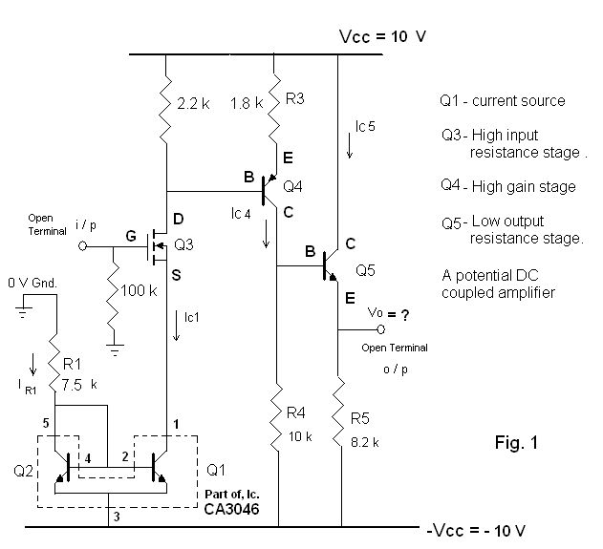

**Conclusion:**

Through this lab, I was able to better understand how to make measurements on the multistage transistor circuit. A pair of matched transistors was selected and operated as a mirror current generator-the source biasing of all stages. The transistors utilized from the pSpice library was the 2N3904. By using the transient response as the simulation settings, I was able to record the quiescent DC values as well as the AC current and voltage values. When comparing the measurements found in the procedure and the calculated values, we can see that the percent variation between the current and voltage values were relatively low, thus, proving that our simulation was successful, and the procedure was followed correctly. This lab continued to further provide fundamental knowledge to amplifiers and small signal circuits.